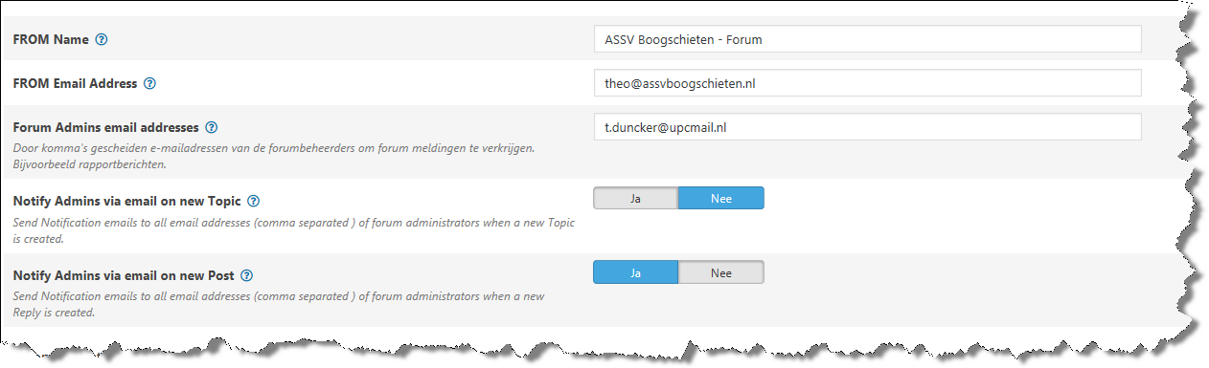
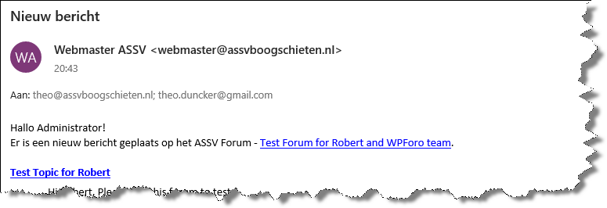
- From email set as theo@assvboogschieten.nl – Received as: from webmaster@assvboogschieten.nl
- Forum Admin is set as t.duncker@upcmail.nl – Received as: for theo@assvboogschieten.nl and theo.duncker@gmail.com
- Forum Admin t.duncker@upcmail.nl is not receiving emails.

